**Ex. No.: 6** Date: 03-03-2022

**Problem statement:**

Create and save an XML document at the server, which contains 10 users Information. Write a Program, which takes user Id as an input and returns the User details by taking the user information from the XML document.

* The registration should be done by XML.
* First should create a login page for the users.
* The user has name should contains only Alphabets and the Password must be of specific length and should contain alphabets, numbers, special characters.
* The user information should contain at least address, phone number and email.
* The user information should contain more than 10 users.
* The data set can be use of students.

Login page:

Username:

Password:

register

login

User information page:

Edit

User Id:

Roll no:

Name:

Father name:

Branch:

Year:

Email:

Address:

* If the user wants to edit, then valid the user by OTP. OTP generated using random number, it can send to mail or phone.

**Design: (Block diagram)**

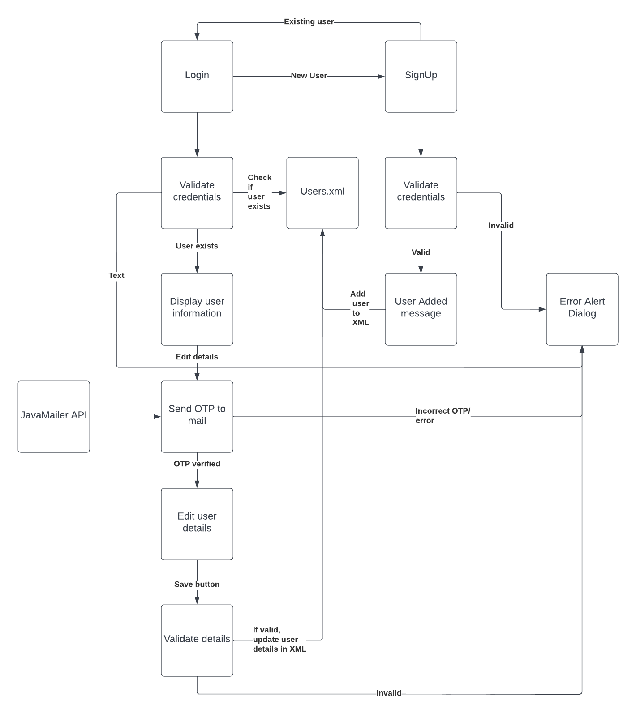

**Tool used:**

* Apache Tomcat
* NetBeans IDE
* Java JDK
* XML
* AJAX
* JSP
* Java Servlet
* Java DOM Parser
* JavaMail API
* HTML
* CSS
* Javascript

**Code:** <https://drive.google.com/drive/folders/13zaEwlM1chssaG3o6DIjMNvkgGRRD-iH?usp=sharing>

**Screenshots of the Output:**

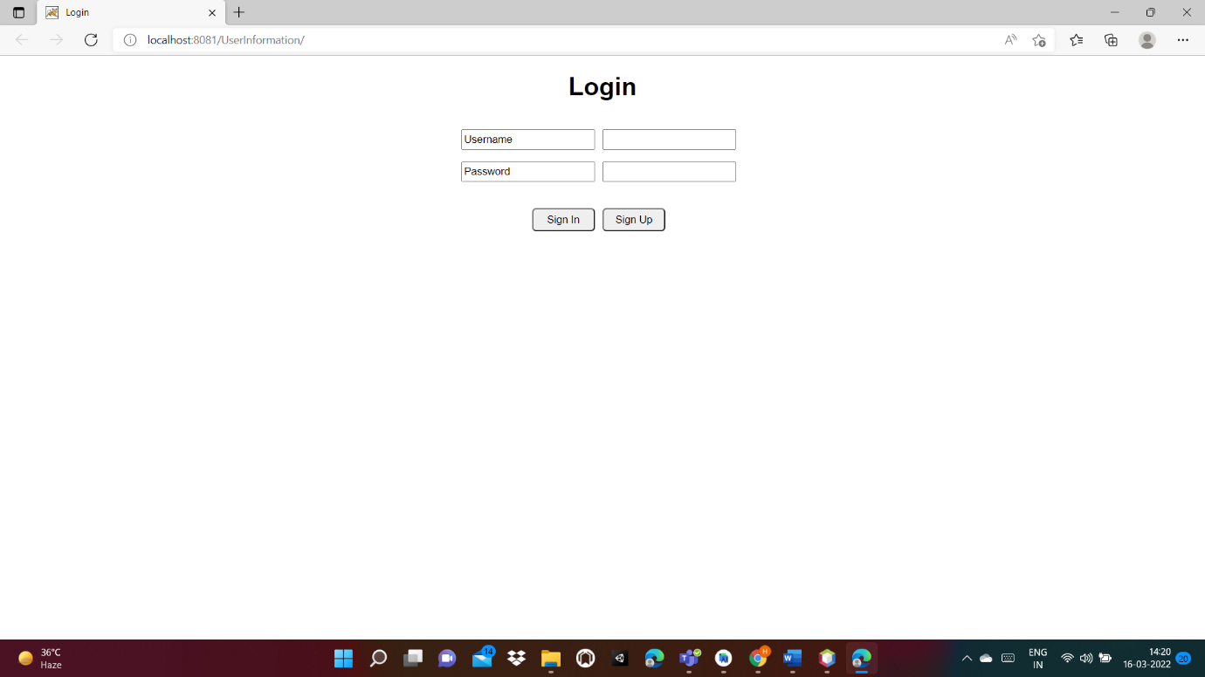

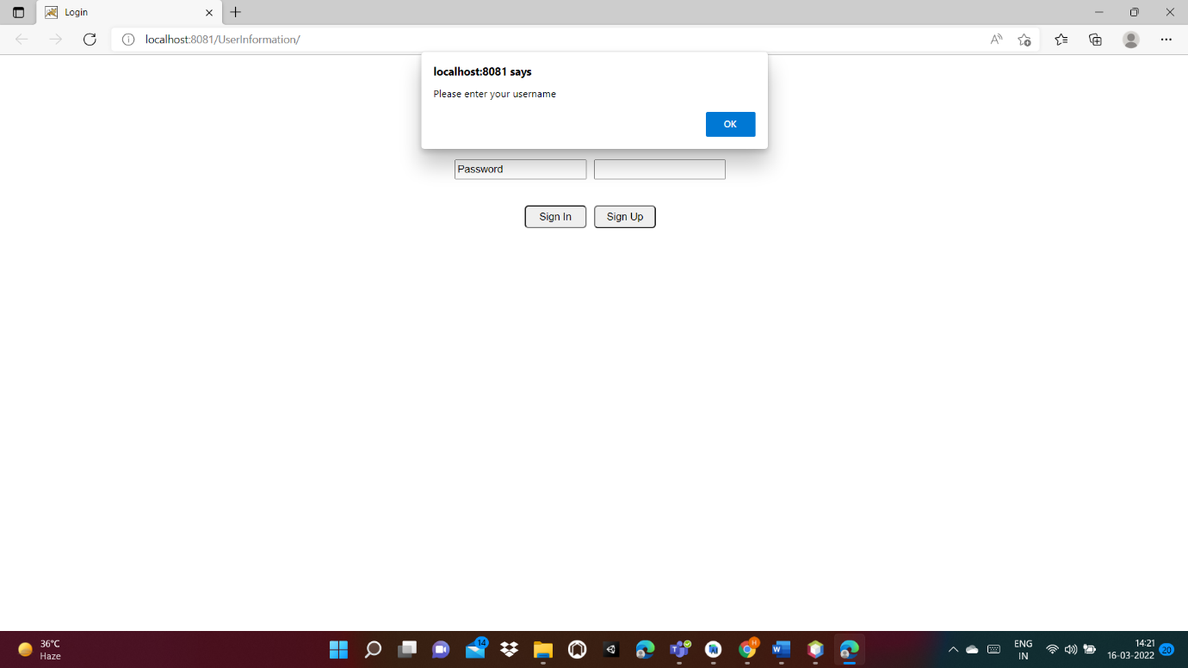

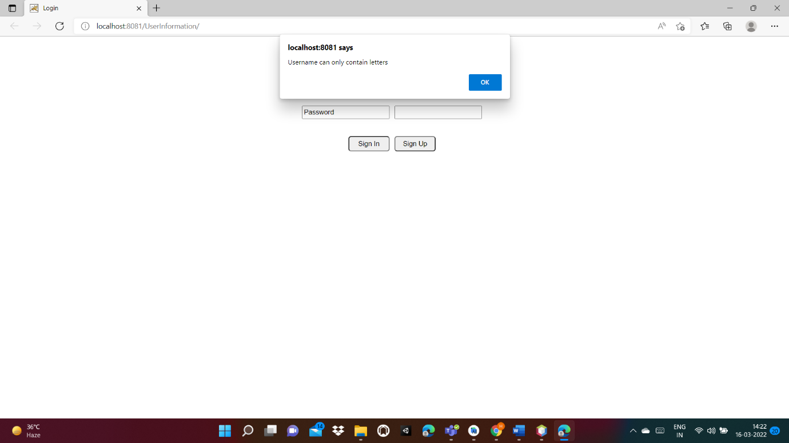

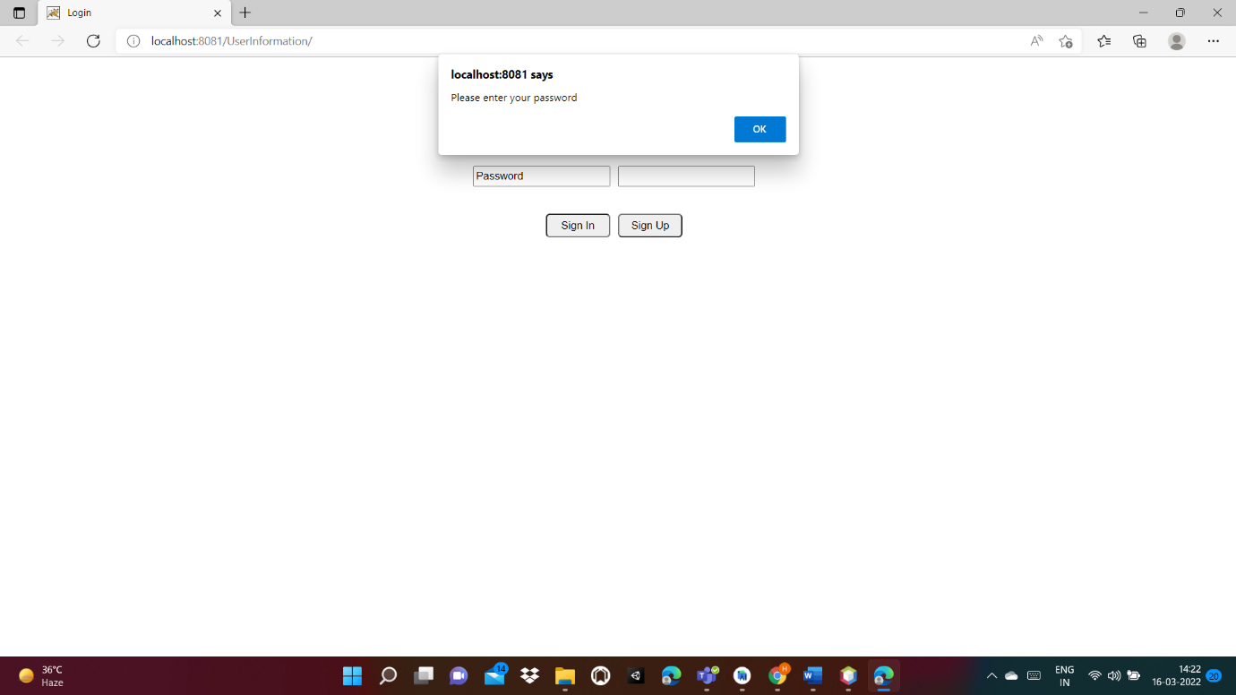

Logging in using invalid credentials:

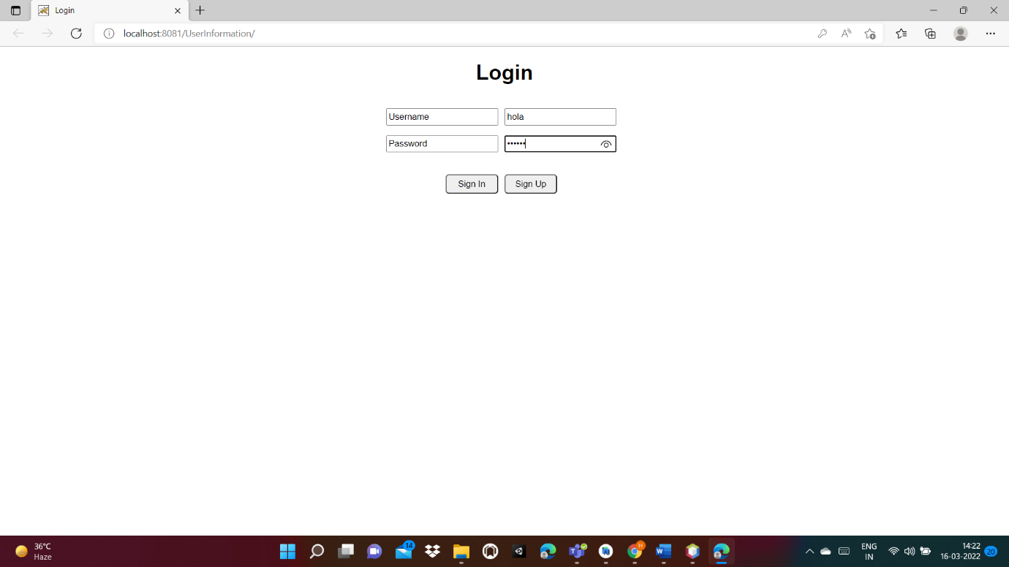

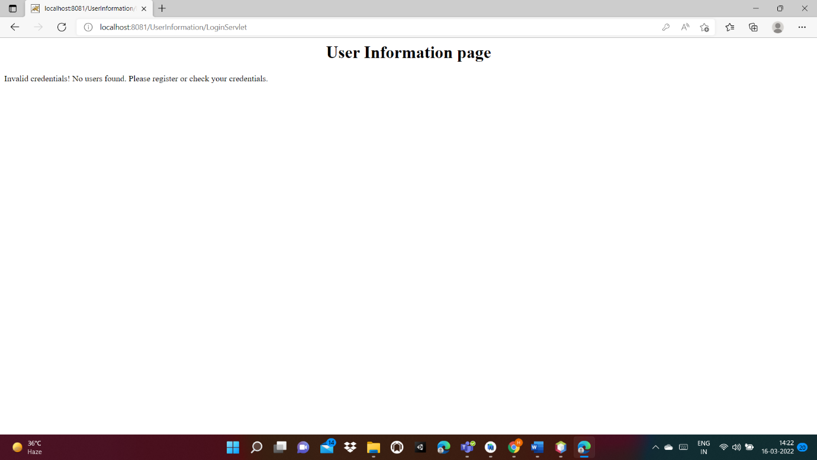

Logging in with existing user:

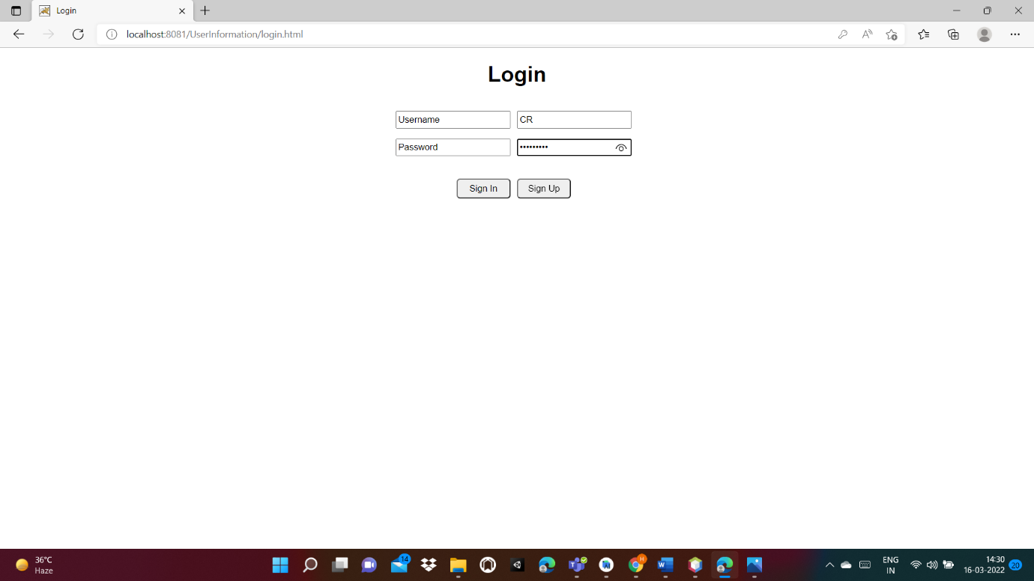

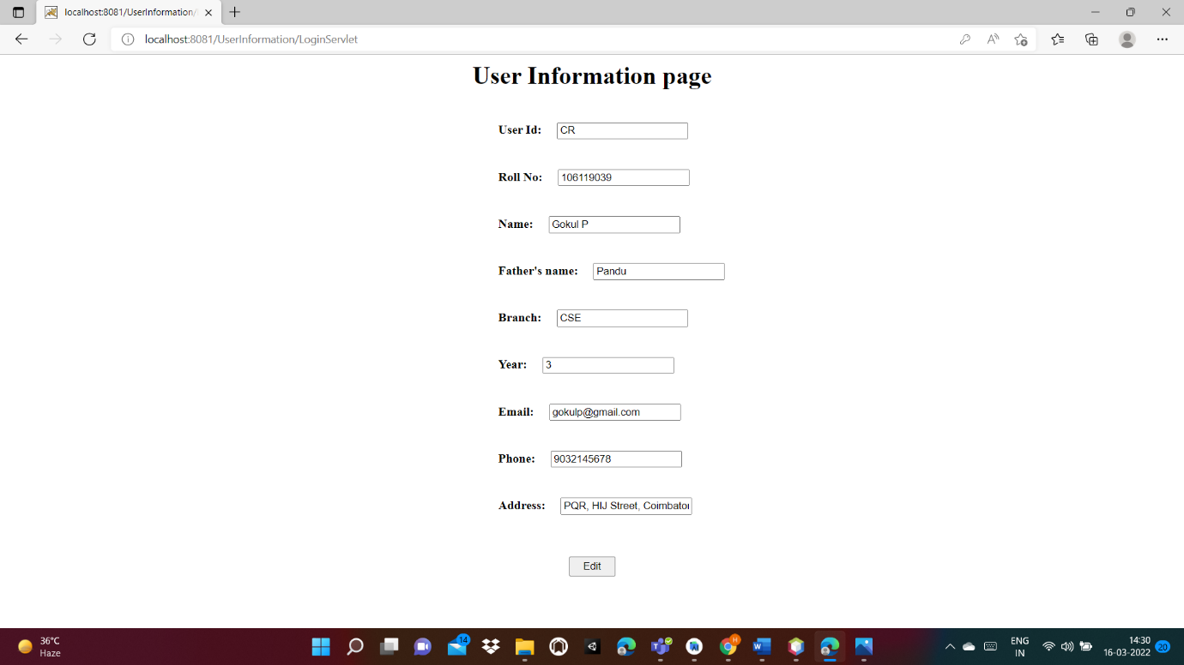

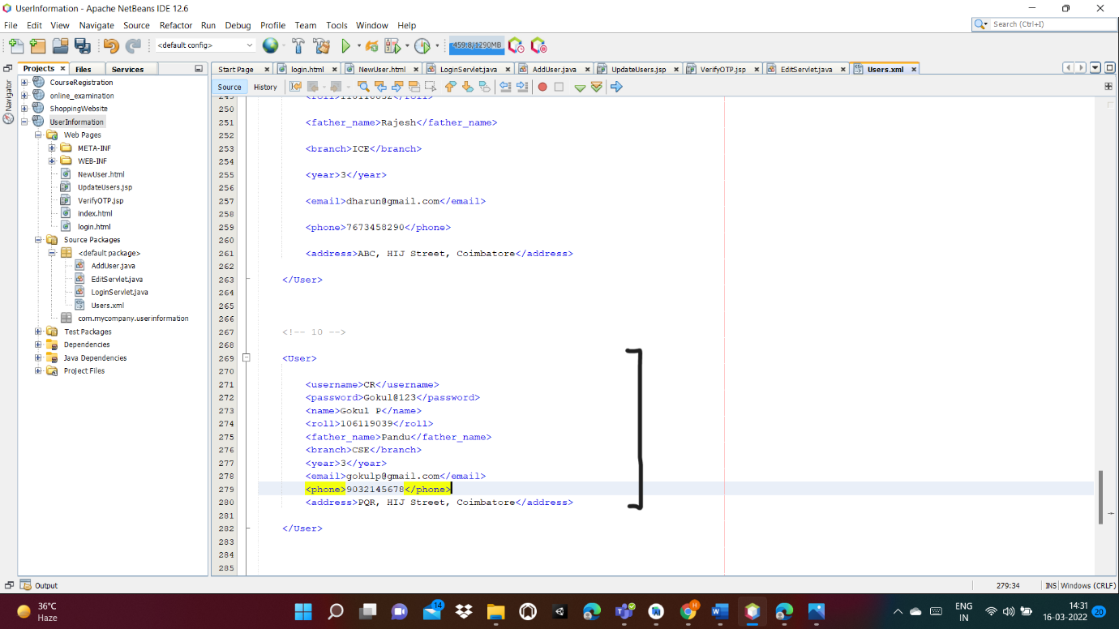

Logging in by creating a new user:

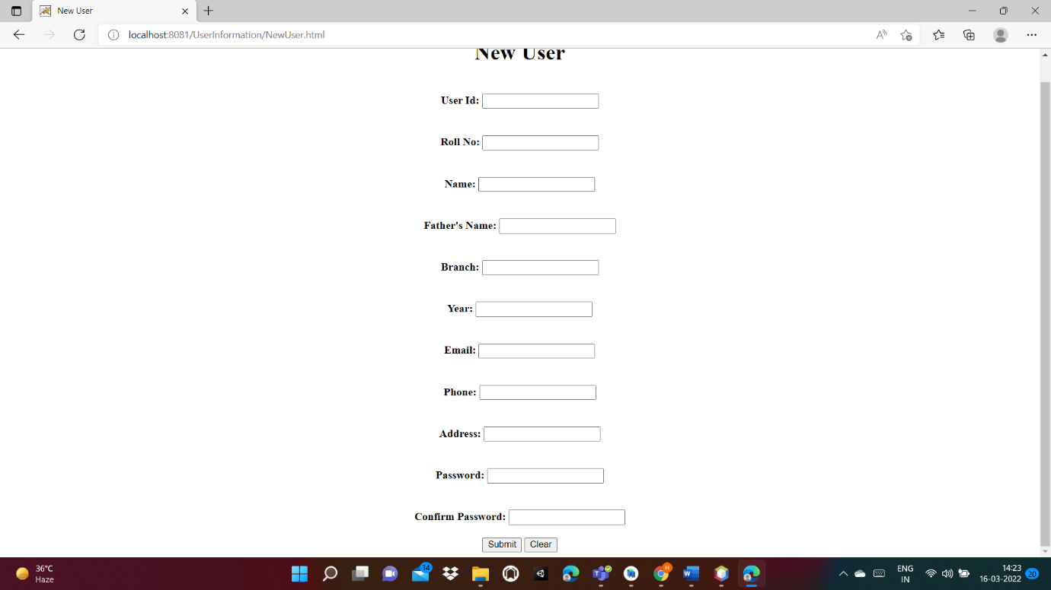

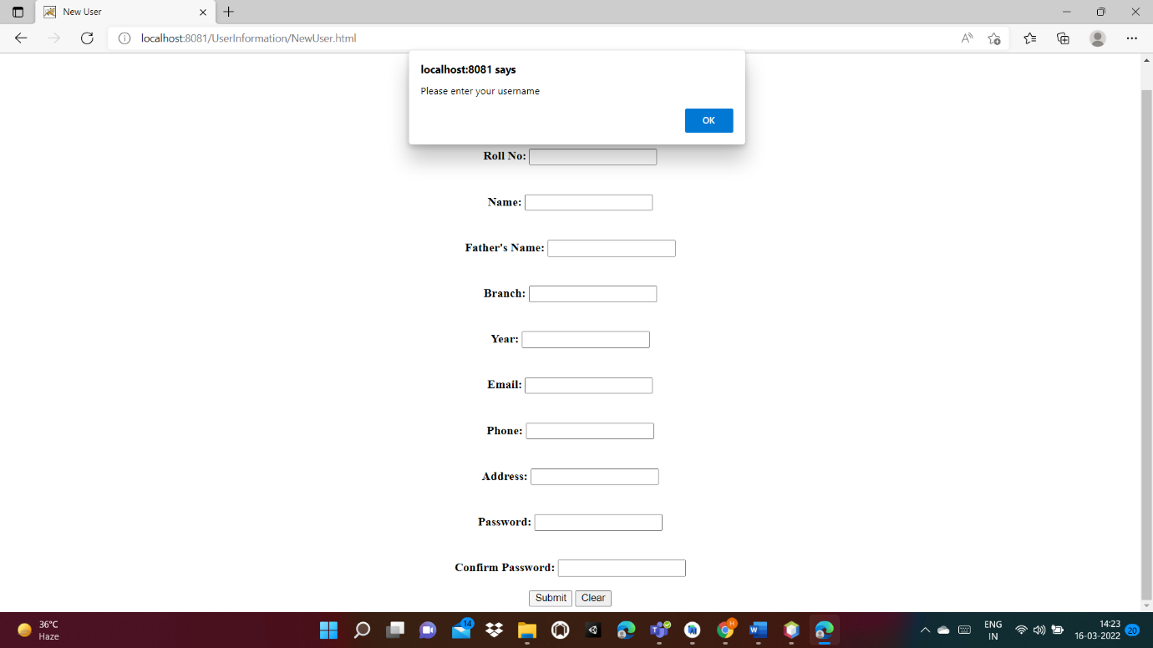

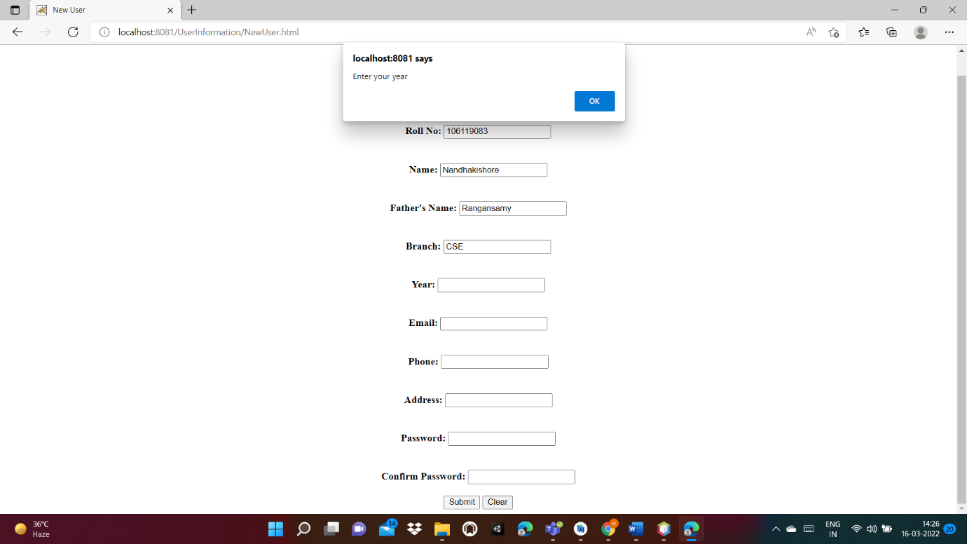

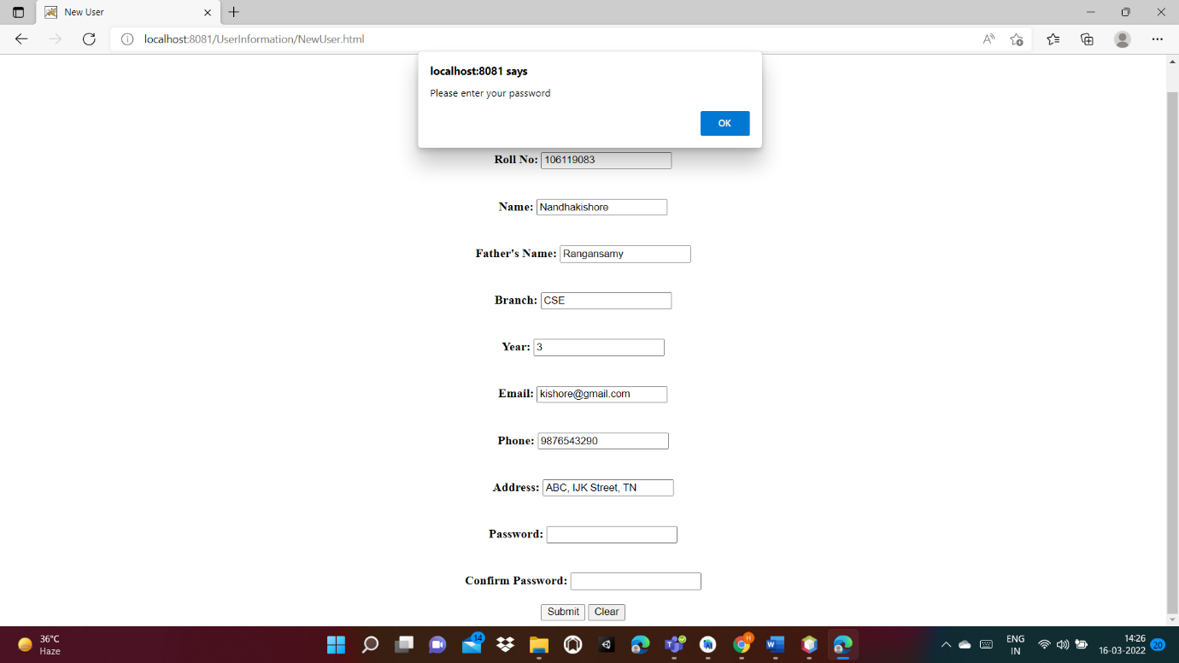

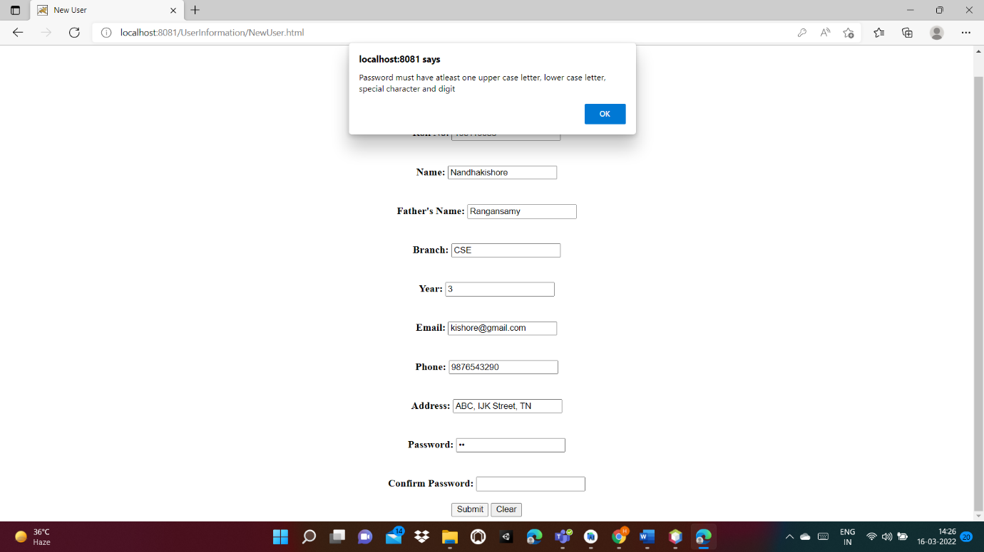

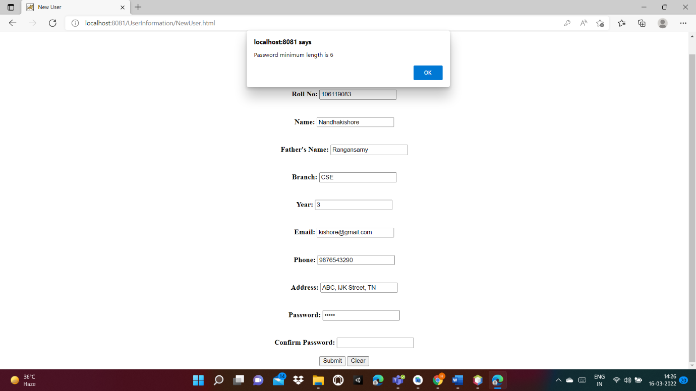

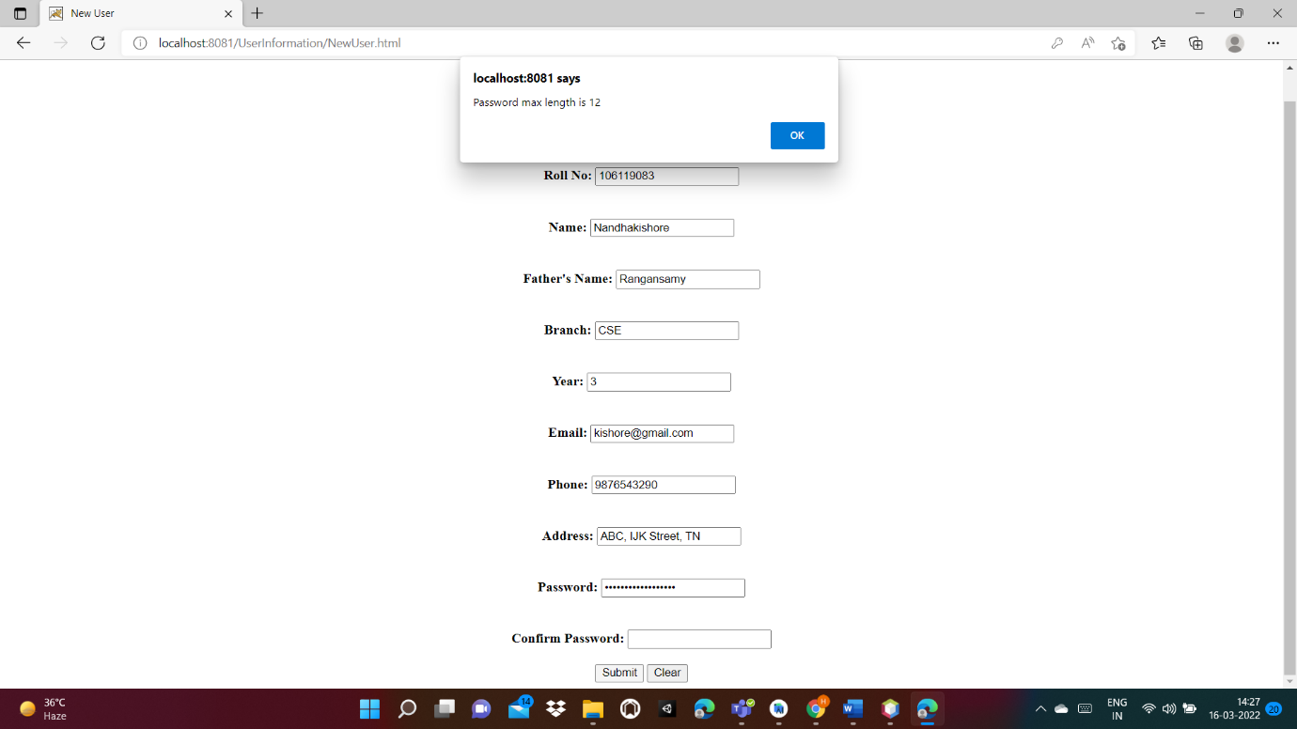

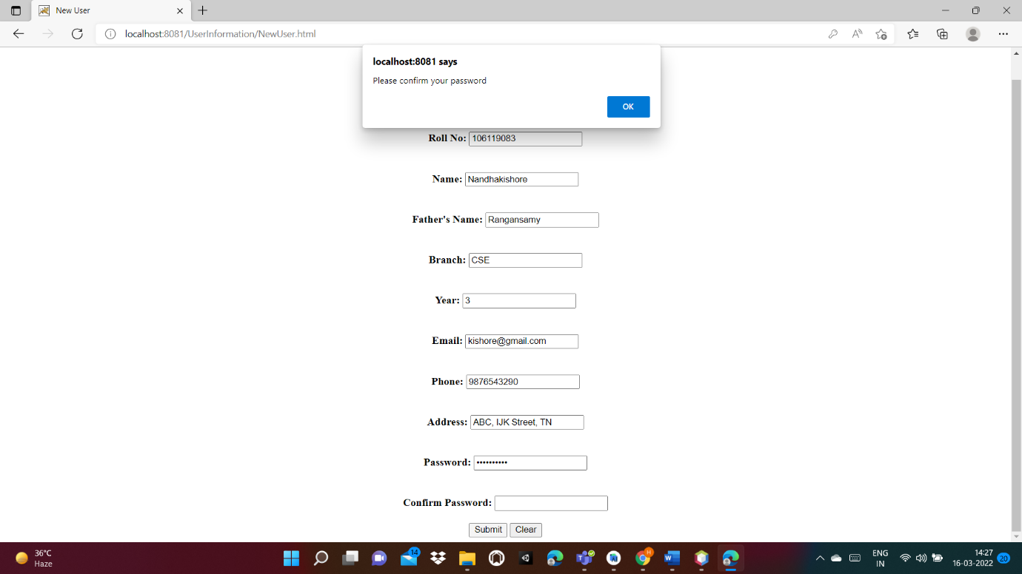

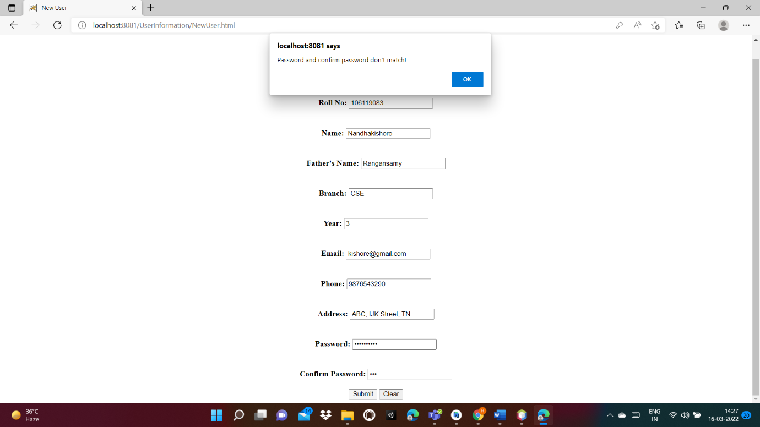

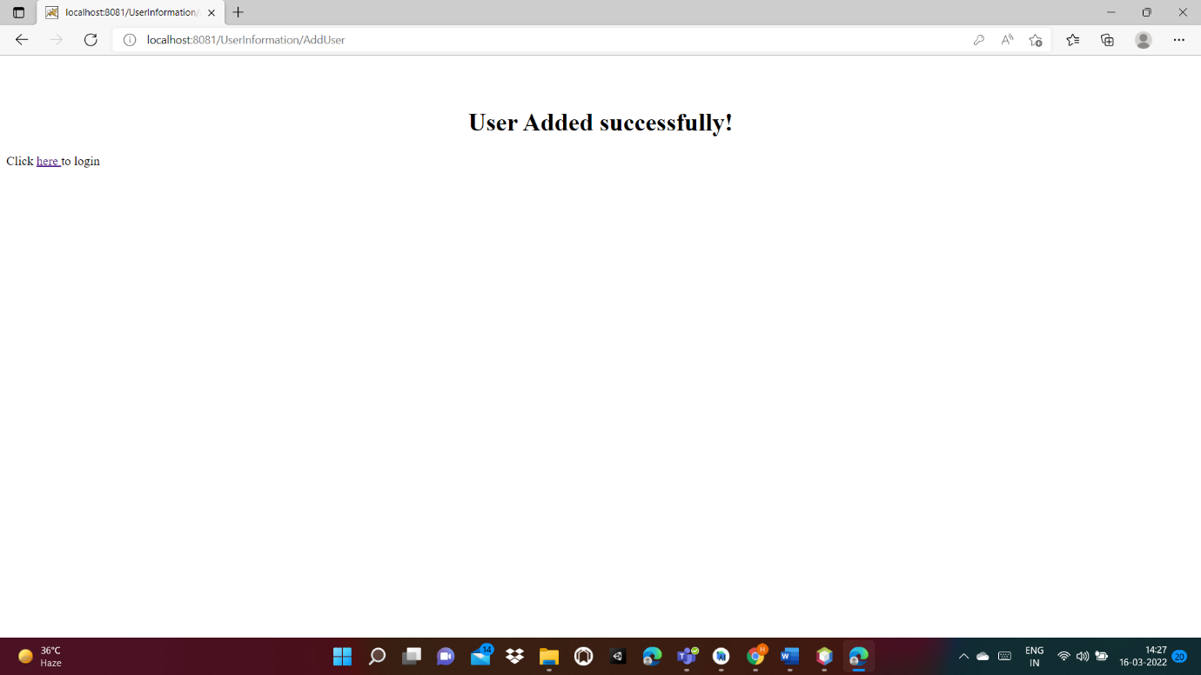

Modified XML file:

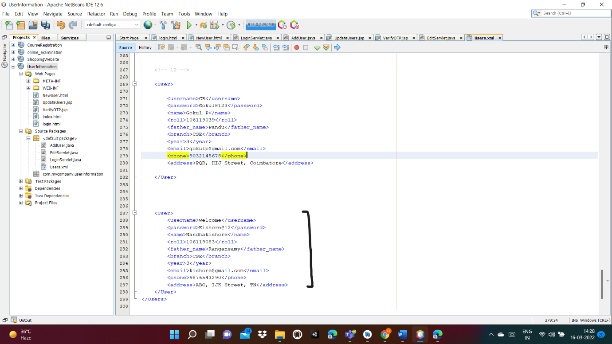

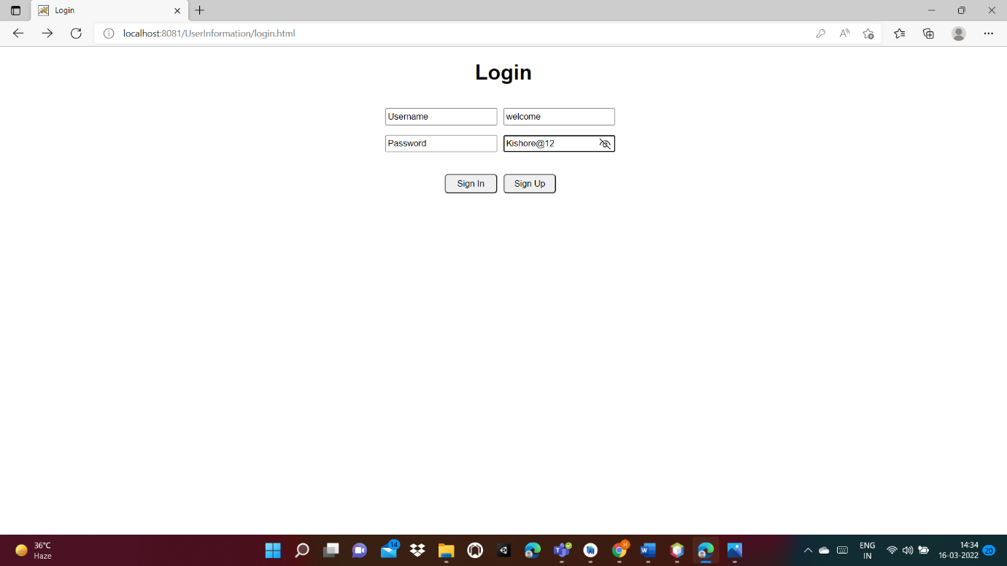

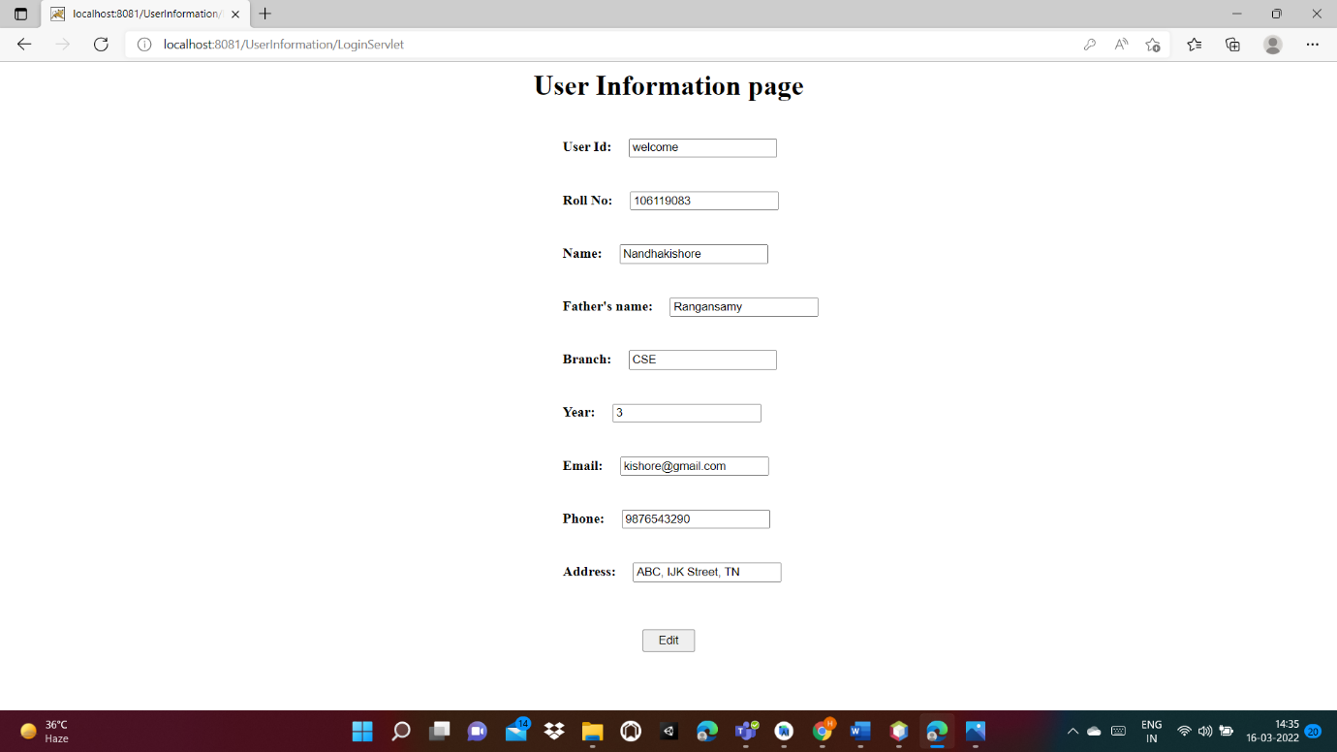

Edit details using OTP:

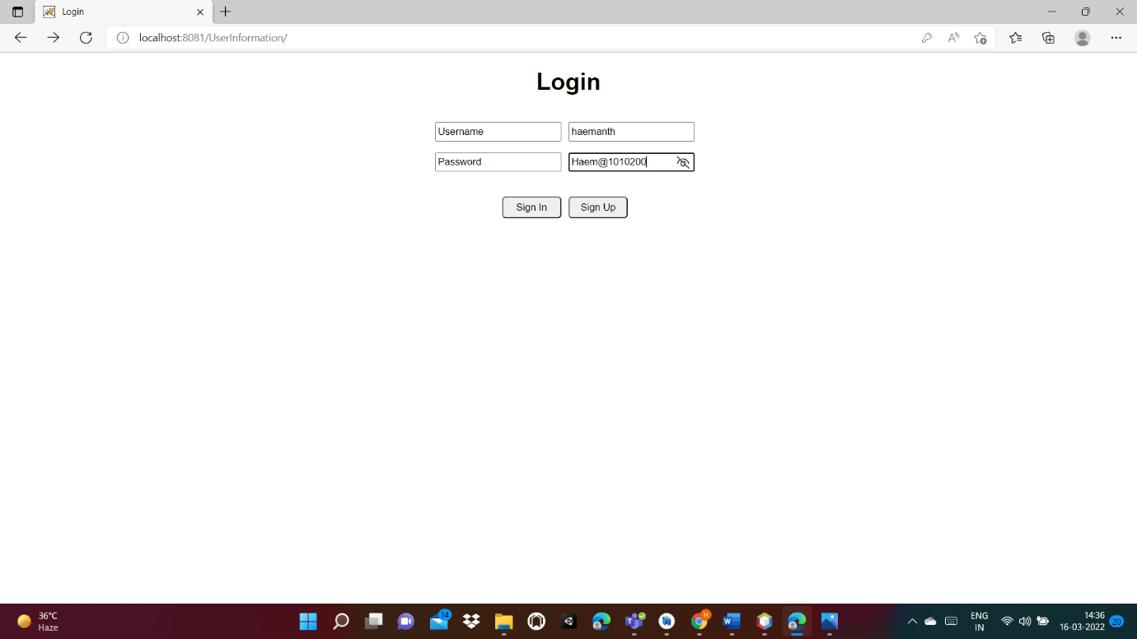

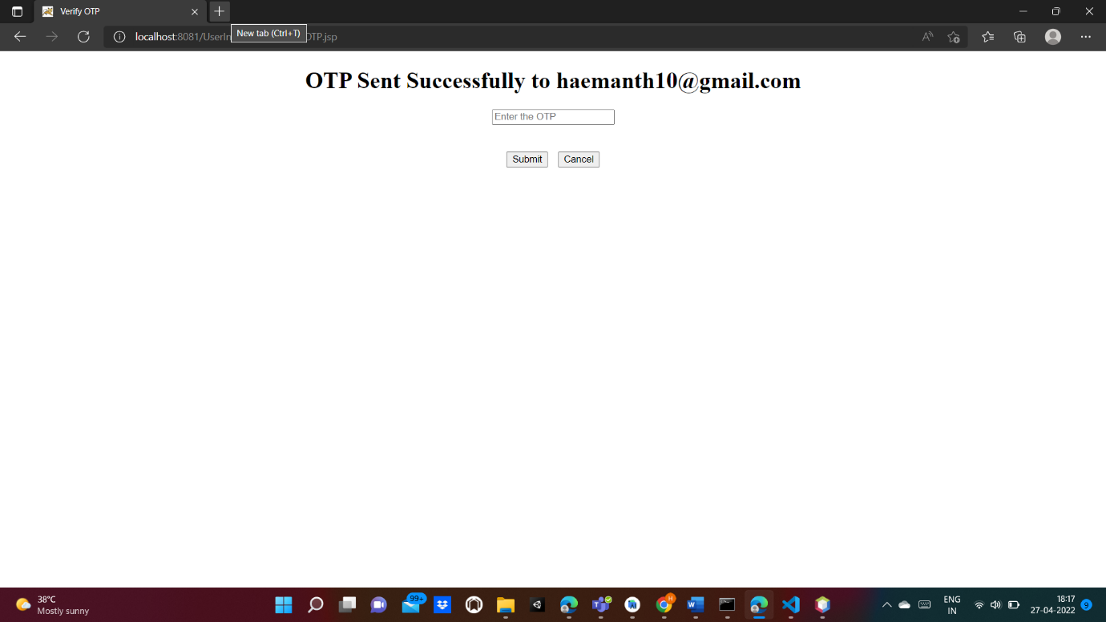

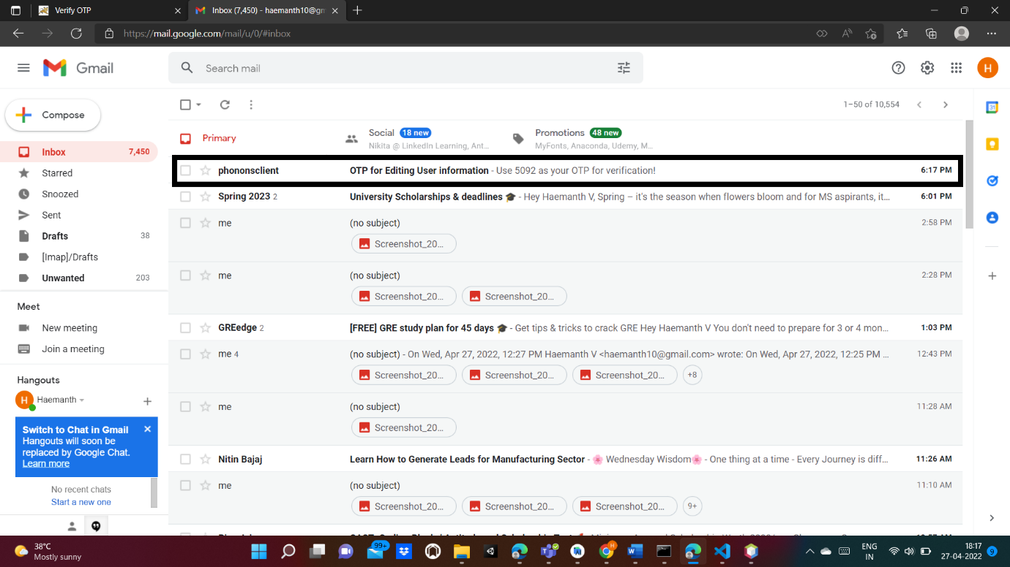

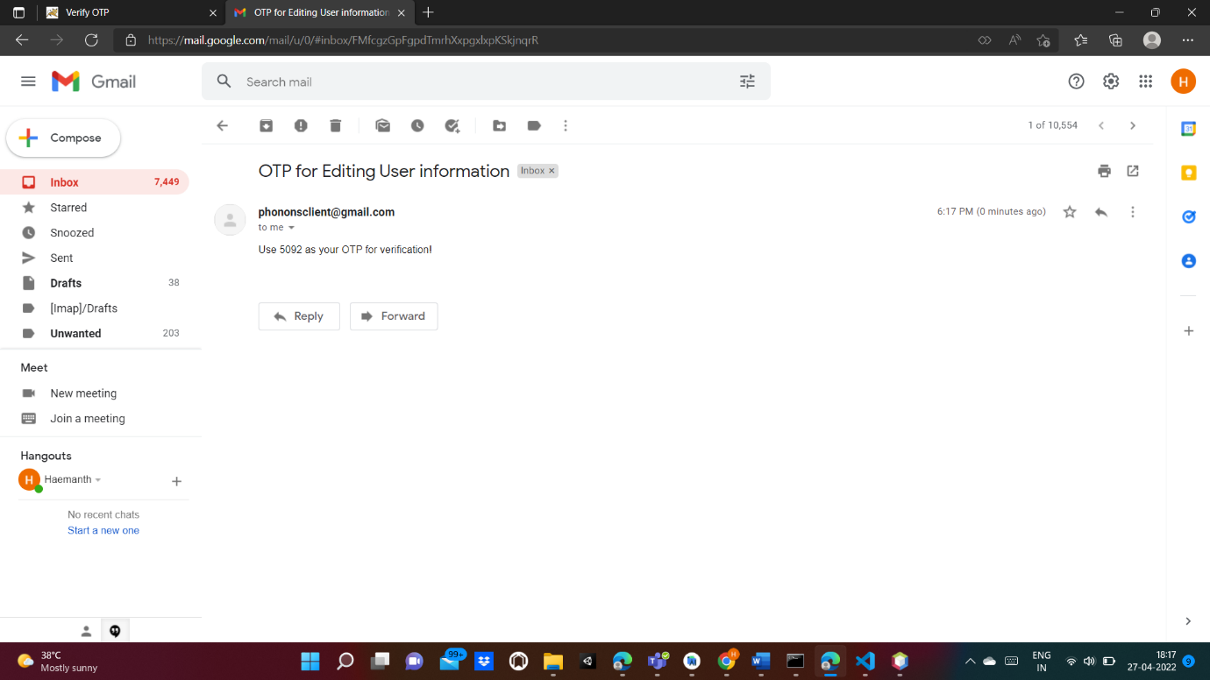

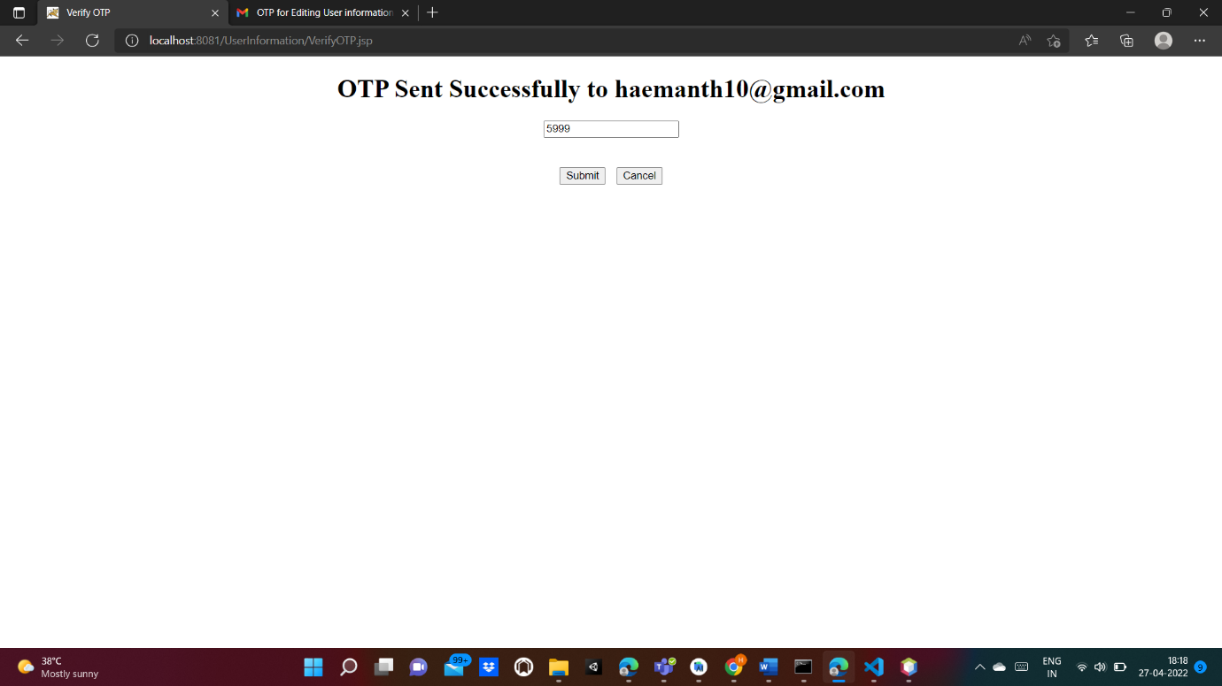

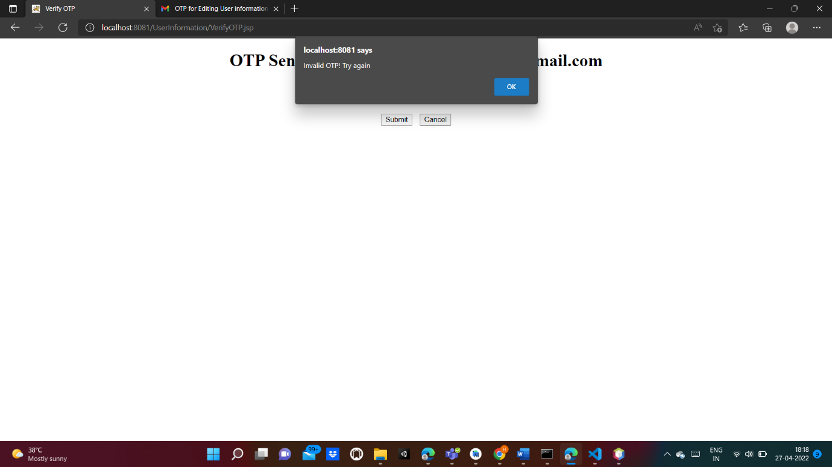

Entering correct OTP:

